CSP North West Regional Network

Tuesday 28th November 2017, 6.00-8.00pm
Education Centre, Chorley Hospital

MINUTES

Present: Jo Lishman - Chair (East Lancashire); Lindsay Cutts (Salus); Daphne Dawson (retired); Sheila Dryden (Fylde & Wyre); Emma Garner (Mojo Pilates); Mobeen Janjua (East Lancashire); Rebecca Maclachlan (Bolton Foundation); Karen Martin (East Lancashire); Nena Mitchell (Aintree); Anne Moss (Lancashire Care); Ruth Squire (Lancashire Teaching); Donna Stephenson (Lancashire Care); Jackie Stokes (Lancaster); Karen Willcock (Bolton Therapy); Julie Wright (Manchester Metropolitan University); Harriet Yale

Apologies: Matt Dennies (Warrington & Halton), Susan Pattison (SP Therapy Services)

1. Chair’s Report – Jo Lishman
CSP Key Messages - www.csp.org.uk/documents/december-2017-ern-key-messages
JL reported that the governance review had been completed with a new structure of 12 elected members and 3 committees. JL previously expressed concern re: representation via email with loss of “Rep to Council” role from Regional Network.

JL reported that the membership review had been undertaken and there had been an increase in the number of associate members.

JL confirmed that there would be a campaign to promote physiotherapy in 2018 with a patient focus (to replace Workout @ Work Day).

JL reported that there was a suite of campaign materials available on the CSP website including PhysioWorks which would be coming to its planned end this year. JL confirmed that the legacy of the PhysioWorks programme was for members to keep up the momentum as further evidence-based briefings would continue to be available. JL reported that systematic reviews of red flag symptoms had been commissioned by the CSP along with a consensus study. RS confirmed that the Red Flag work had been discussed at Physiotherapy UK. JW enquired as to whether it would be possible to have James Selfe or Sue Greenhalgh speak at a future study day.

JL confirmed that the deadline for the NICE fellows and scholars was 15th December 2017.

JL reported that Shaping Physio was the name of a new campaign to increase practice-based learning #prblcsp

ACTION: JL to speak to Sue Greenhalgh re: red flag update for members.

Feedback from Research Project
JL confirmed that the Research Project report had been received. JL stated that there had been a high proportion of female respondents and queried whether this was representative of the North West. KW reported that the CSP is 52% female and this is also representative of Physio First members. MJ confirmed that he used patient specific outcome measures (PSFS) as well as patient experience data. JL reported that MSKHQ had been validated for use in all MSK conditions but was awaiting testing for rheumatological conditions. The membership discussed appropriate community outcomes measures such as TOMS (used by KM and JS).

ACTION: NM to post report on website.

ARC Motions for 2018
JL confirmed that the deadline for ARC motions was 30th November 2017. MJ reported that his previous ARC motion re: sedentary behaviour had been rejected. JW recalled a cartoon from the DoH re: sedentary behaviours ‘?’fat Brenda’. The membership discussed ARC motions but no consensus was made.

2. Issues from Key Council Papers – Ruth Squire
RS reported that most issues had been covered under the Key Messages in the Chair's Report.

RS confirmed that, after 20 years, self-referral was finally coming to fruition.

RS reported that, despite a 15% increase in training places in England, this was not sufficient to meet service needs. JW confirmed that a fall in available placements meant that HEIs were continuing to struggle to meet demand.

RS confirmed that the apprenticeship agenda was moving forward. JL confirmed that she had been involved in designing a module and the successful bidder to host the module was UCLan.

RS reported that the CSP was continuing to seek further case studies to populate the website. KM enquired as to why so many case study submissions were from the South.

KW and KM have been interviewed to participate in the CSP Leadership programme.

DD asked how the CSP members on the Isle of Man would be represented in the new Council framework.

RS confirmed that the 3 committees on Council would be:
- Professional
- Employment
- Finance, Risk and Audit

KW confirmed that NHS employed CSP members represent a very small majority.

RS confirmed that the CSP had moved to a new eportfolio system.

ACTION: RS to email report to NM to post on website.
RS to ask Council how Regional Networks will feedback to Council/ be represented
Proposed ARC motion for next year: record other employment on CSP website.

3. Secretary’s and Communications Report – Nena Mitchell
NM reported that Manchester University were undertaking a NHS @ 70 project and were seeking information from anybody who had information about working within or receiving treatment from the NHS, particularly in the early years.

NM confirmed that a report had been received from Susan Pattison re: social media.

4. CSP Branch Reports – Cumbria and Macclesfield
NM reported that all events received from the Branches had been posted on the CSP website.

ACTION: NM to contact branches for update.

5. Social Media Strategy and update – Susan Pattison
NM confirmed that the following report had been received from Susan Pattison:

“Initially access to the NW CSP Twitter account was unavailable so I set up @PhysioForGM to specifically publish tweets about Devo Manchester based on the Buzzing with Ideas 2017 document. This was active until approximately May when after the bombing it didn’t seem appropriate. This is now up and running again. The highlight was the Conservative Candidate contacting the CSP and this led to a face2 face session, enabling us to discuss the importance of Falls Prevention and featured in Frontline.
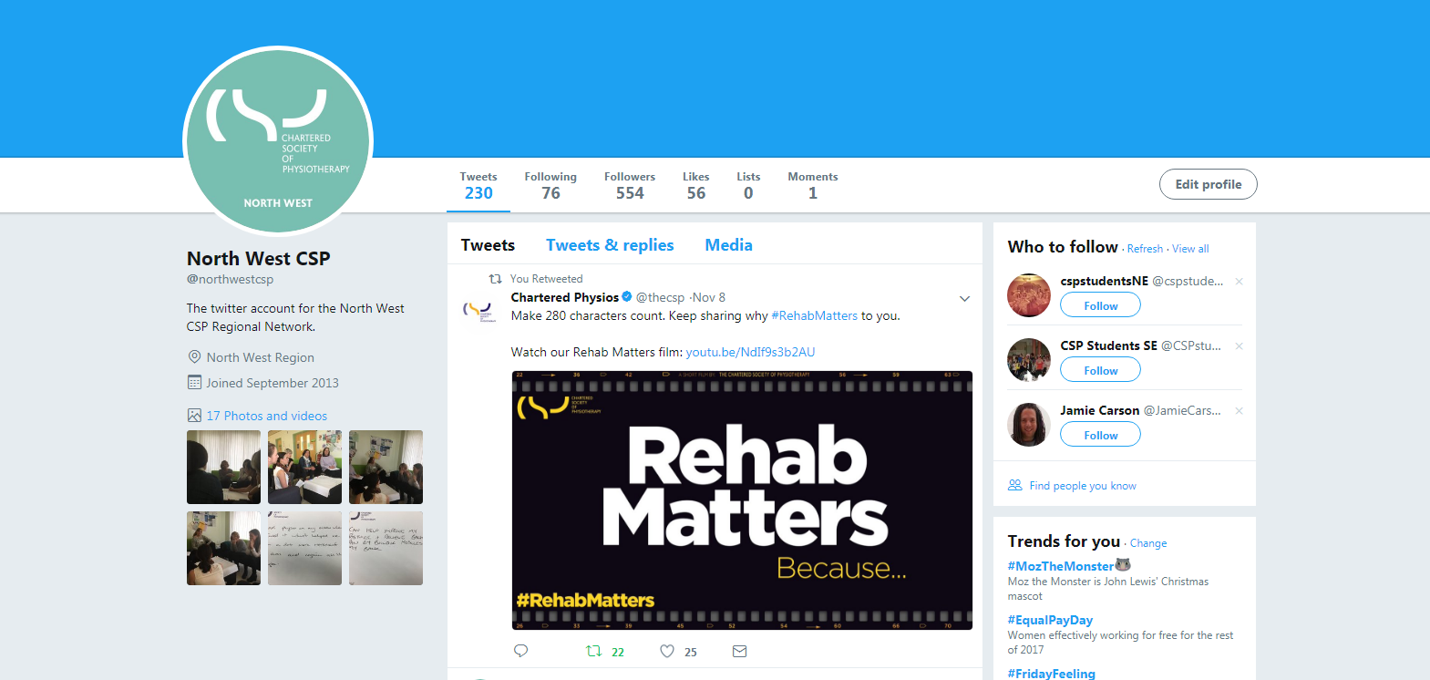
With the CSP’s new emphasis on regions the issues with the Twitter account were unlocked and we got a shiny new official logo. With Jo’s permission I took over as lead on 10.11.17. This coincided with PhysioUk2017 which I thought was an ideal time to engage and I started with tweets featuring items from The Think Physio Act Local pamphlet and sign posting members to our meeting and the web site. My plan is to use the Key Messages Documents to continue to update the feed. A summary of the engagement with the account to date is attached. Any other ideas always appreciated.”

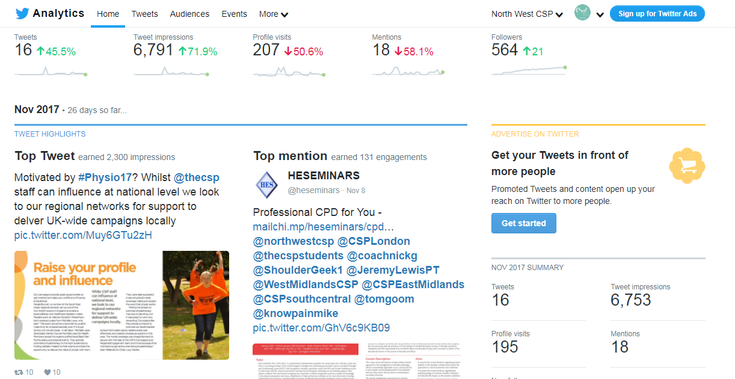

6. Minutes of the previous meeting
Study Day Feedback
The members discussed preparations for the next Study Day. JL confirmed that, as the poster winner was unable to attend Physiotherapy UK, the prize money had been paid into their Learning & Development Fund. JL asked that the members consider co-hosting the next Study Day with the North West AHP network.

Geraldine Chitty Fund
JL confirmed that the amount of £500 per year was available for this fund. This year, half had gone to the Study Day poster winner with the remaining half going to Naomi Bold to help her present at a Stroke Conference.

7. Matters arising
There were no matters arising.

8. Any other business
There was no other business to attend to.

11. Date of next meeting
NM asked the membership to agree to the following dates for 2018:

Monday 26th March (MMU)
Tuesday 12th June (Chorley)
Monday 17th September (MMU)
Tuesday 4th December (Chorley)
The membership agreed to the above dates.

ACTION: NM to put meeting dates on Regional Network website.

